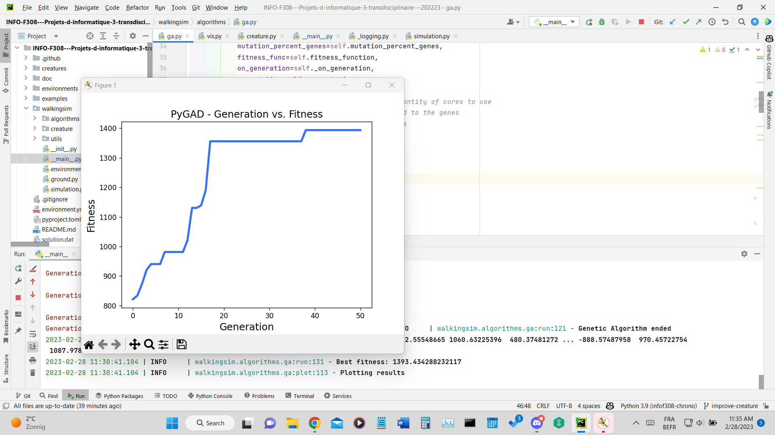

population_size = 100

GA = GeneticAlgorithm(

population_size=population_size,

num_generations=50,

num_parents_mating=4,

mutation_percent_genes=10,

num_joints=4,

parallel_processing=None,

init_range_low=-1000, # init range applied to the genes

# which in this case are the forces/angles

init_range_high=1000,

random_mutation_min_val=-1000,

random_mutation_max_val=1000,

parent_selection_type="tournament",

keep_elitism=population_size // 100,

crossover_type="uniform",

)

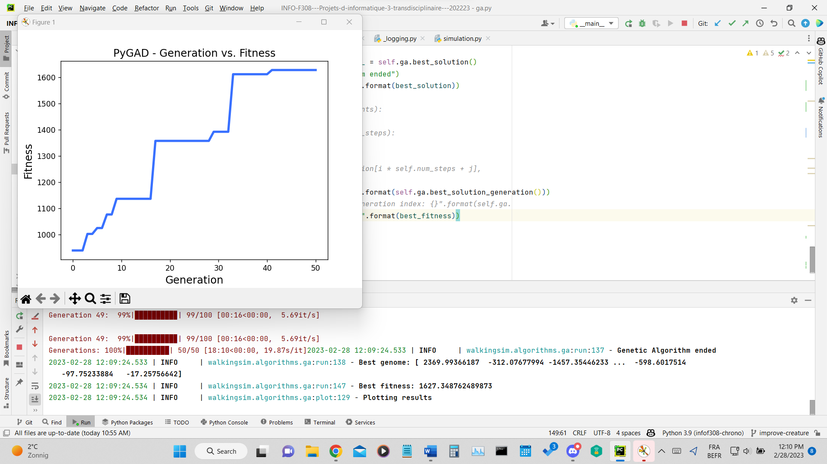

population_size=20,

num_generations=2,

num_parents_mating=4,

num_joints=8,

num_steps=_GENOME_DISCRETE_INTERVALS,

parallel_processing=None,

# init_range_low=-1000, # init range applied to the genes

# # which in this case are the forces/angles

# init_range_high=1000,

parent_selection_type="tournament",

# K_tournament=population_size // 100,

keep_elitism=population_size // 100,

crossover_type="uniform",

# crossover_type="single_point",

# crossover_type="two_points",

# crossover_type="random",

# UserWarning: Use the 'save_solutions' parameter with caution

# as it may cause memory overflow when either the number of

# generations, number of

# genes, or number of

# solutions in population is large.

save_solutions=False,

mutation_type="adaptive",

mutation_percent_genes=(30,1),

# mutation_type="random",

# mutation_by_replacement=True,

# random_mutation_min_val=-1000,

# random_mutation_max_val=1000,

)

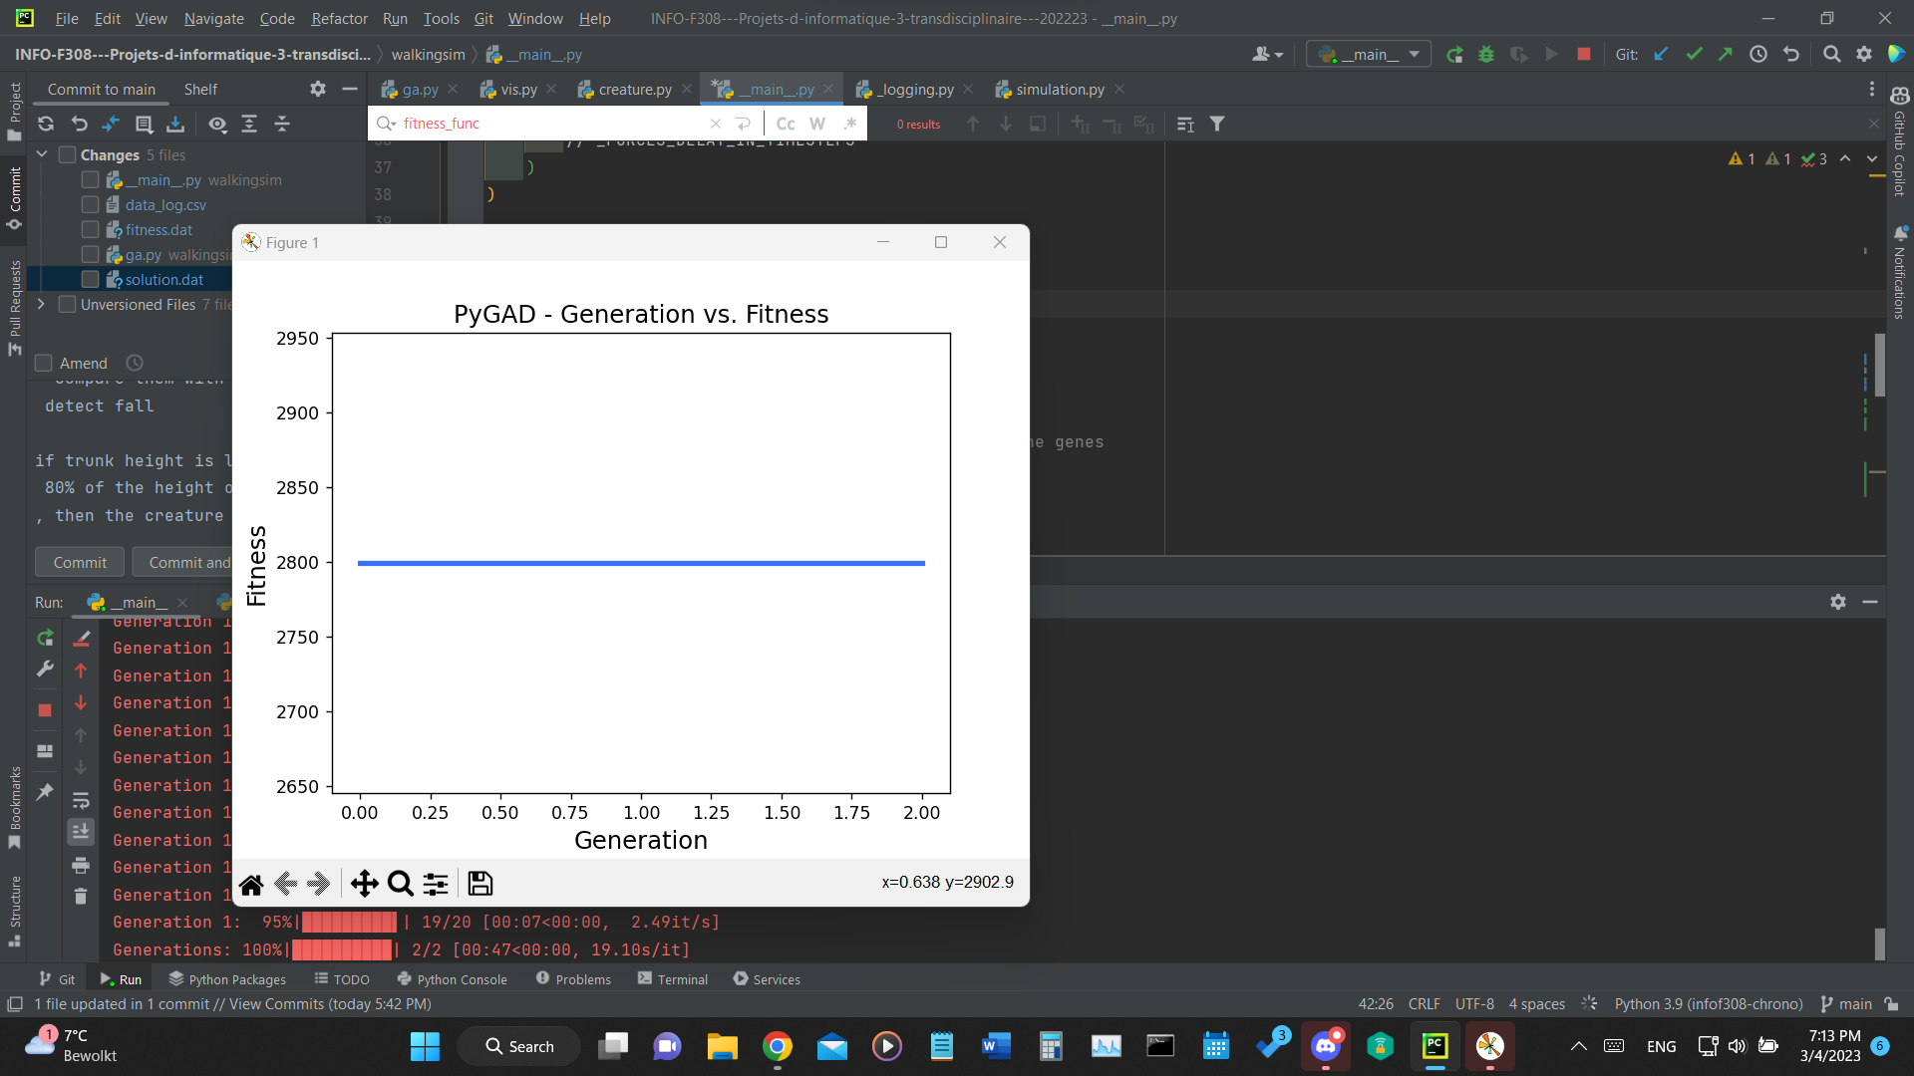

population_size=20,

num_generations=100,

num_parents_mating=4,

num_joints=8,

num_steps=_GENOME_DISCRETE_INTERVALS,

parallel_processing=None,

# init_range_low=-1000, # init range applied to the genes

# # which in this case are the forces/angles

# init_range_high=1000,

parent_selection_type="tournament",

# K_tournament=population_size // 100,

keep_elitism=population_size // 100,

crossover_type="uniform",

# crossover_type="single_point",

# crossover_type="two_points",

# crossover_type="random",

# UserWarning: Use the 'save_solutions' parameter with caution

# as it may cause memory overflow when either the number of

# generations, number of

# genes, or number of

# solutions in population is large.

save_solutions=False,

mutation_type="adaptive",

mutation_percent_genes=(30,1),

# mutation_type="random",

# mutation_by_replacement=True,

# random_mutation_min_val=-1000,

# random_mutation_max_val=1000,

)

mutation_percent_genes=(30,10),

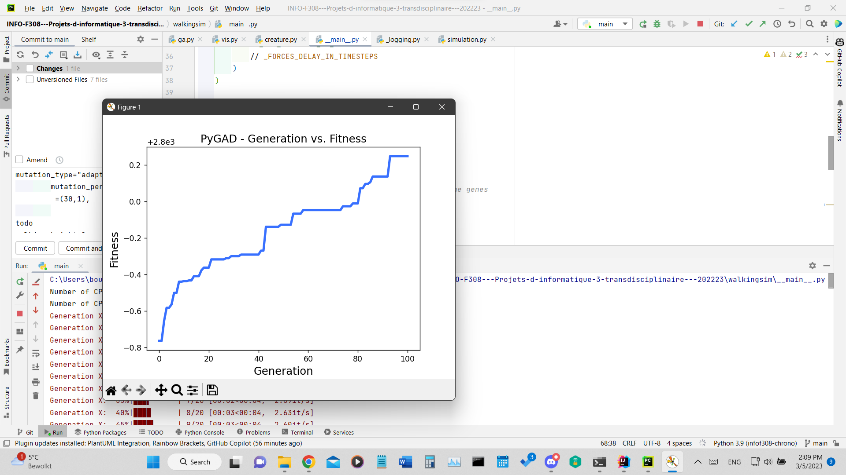

config = PygadConfig(

num_generations=num_generations,

num_parents_mating=4, # TODO: Add argument

mutation_percent_genes=(60, 10), # TODO: Add argument

parallel_processing=None,

parent_selection_type="tournament", # TODO: Add argument

keep_elitism=5, # TODO: Add argument

crossover_type="uniform", # TODO: Add argument

mutation_type="adaptive", # TODO: Add argument

initial_population=None, # TODO: Add argument

population_size=population_size,

num_joints=8, # FIXME: Load this from the creature

save_solutions=False,

gene_space={"low": -1, "high": 1, "step": 0.1},

init_range_low=-1,

init_range_high=1,

random_mutation_min_val=-1,

random_mutation_max_val=1,

timesteps=timesteps,

)